JOB APPLICATION TRACKING SYSTEM

1 INTROUCTION

* 1. Overview

An application tracking system is a tool that enables your company to track and measures each step of its recruitment process. An ATS collects and stores information about you’re a candidates.

* 1. Purpose

When a candidates applies to a job their information to uploaded to your ATS database. Typically, this includes details like contact information, qualification, and resumes

1. PROBLEM DEFINITION & DESIGN THINKING
   1. Empathy Map

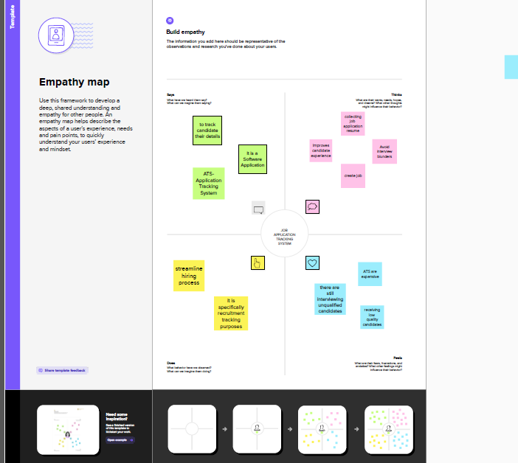

* 1. Ideation & Brainstorming Map

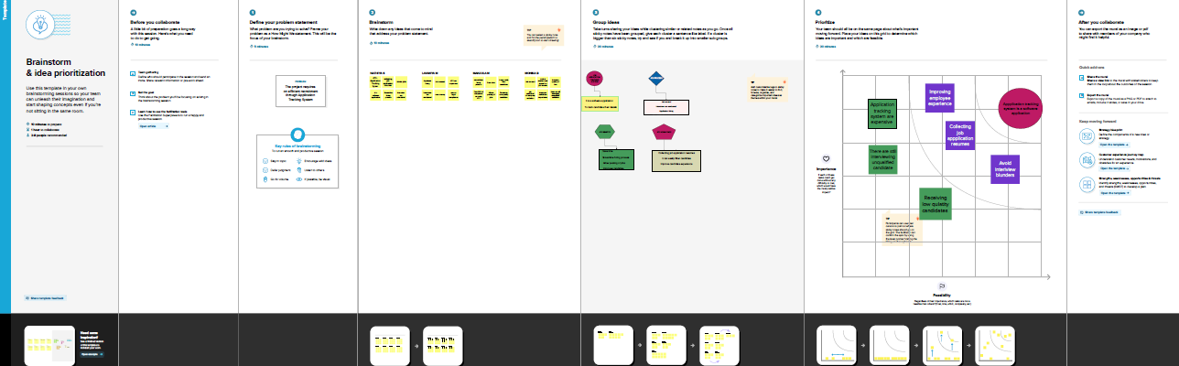

1. RESULT
   1. Data Model:

|  |  |
| --- | --- |
| Object Name | Fields in the object |
| Custom  Object | |  |  | | --- | --- | | Field label | Data type | | Recruiter | Auto Number | |
| object | |  |  | | --- | --- | | Field label | Data type | | Recruiter | Master-Detail realtionship | |

* 1. Activity & screenshot

Milestone2- Object

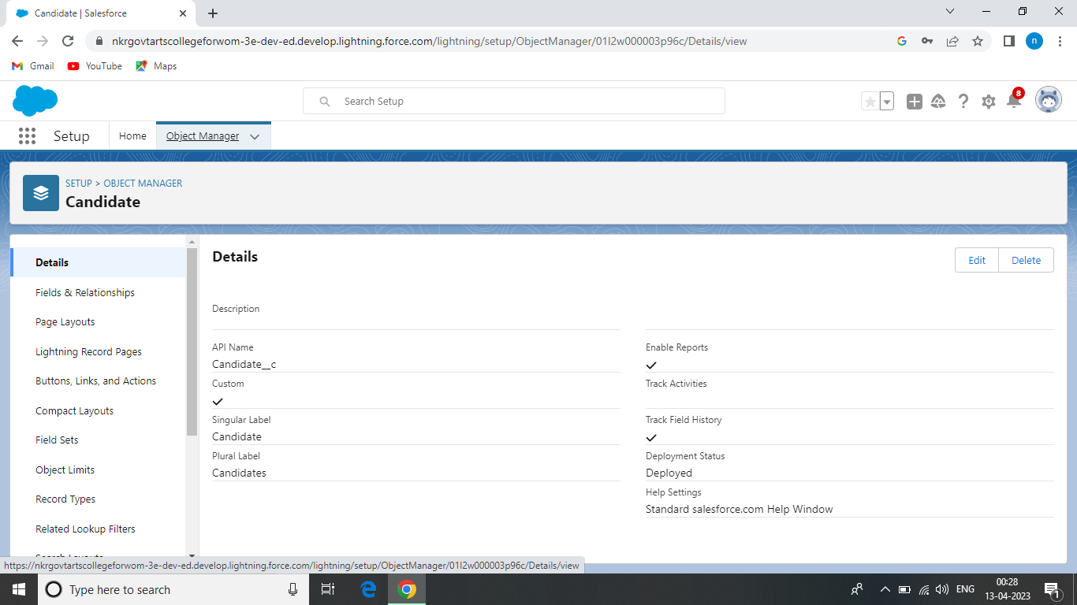

Milestone3- Fields

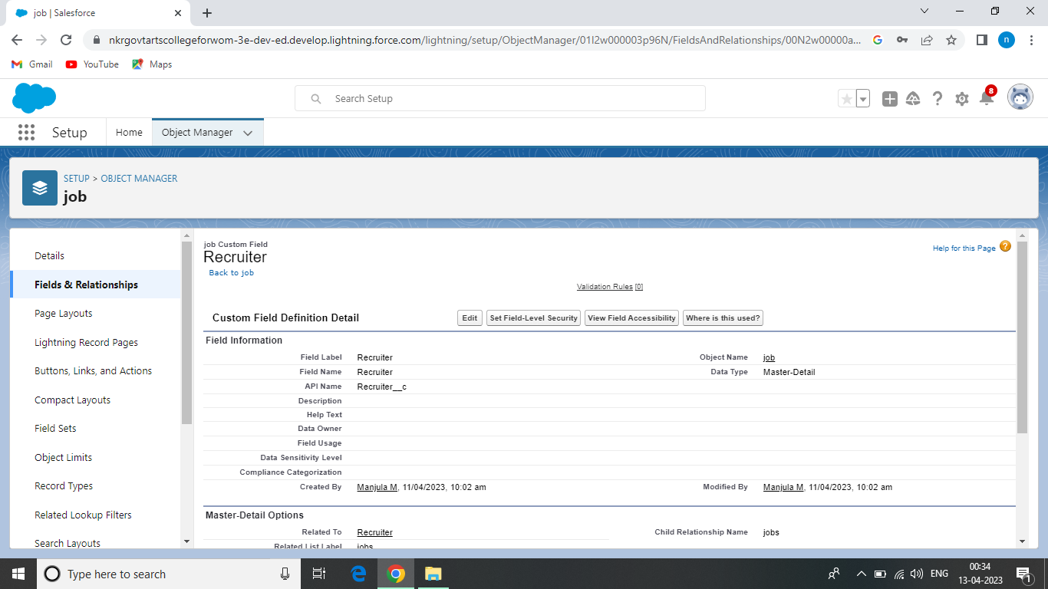

Milestone4- Tab

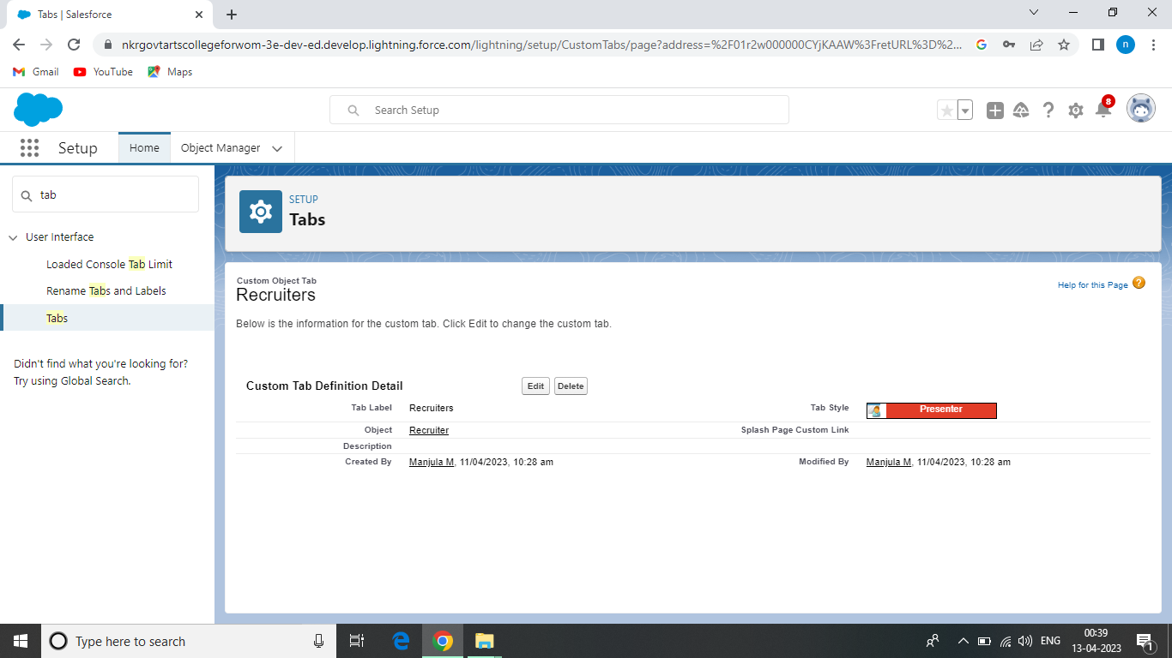

Milestone5- Profile

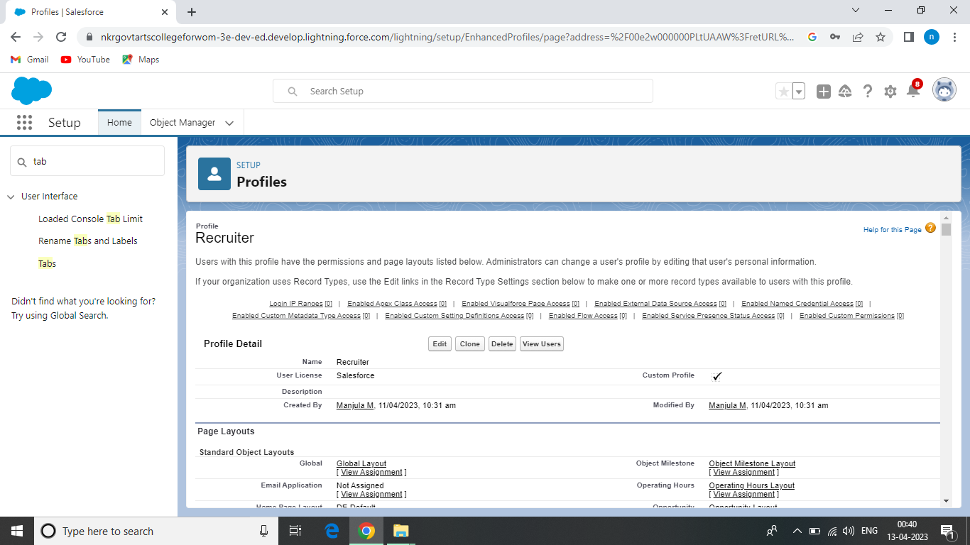

Milestone6- User

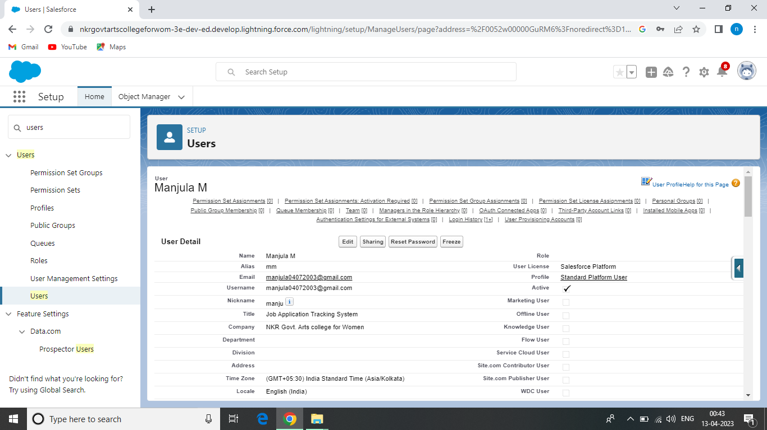

Milestone7- Sharing Rules

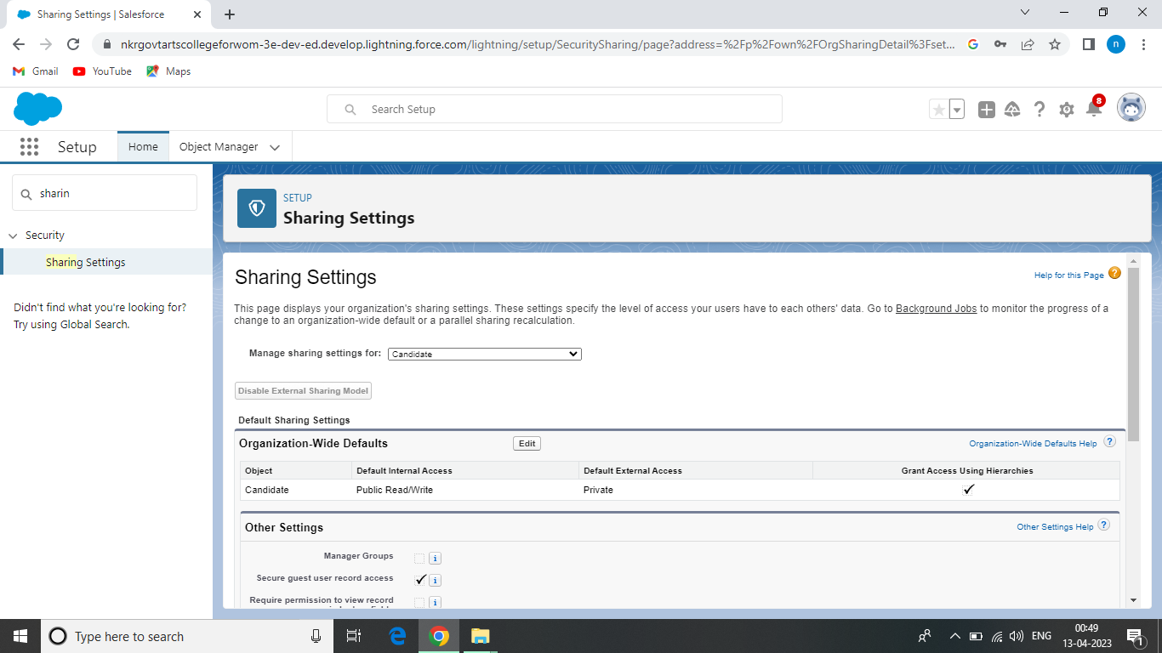

Milestone8- Reports

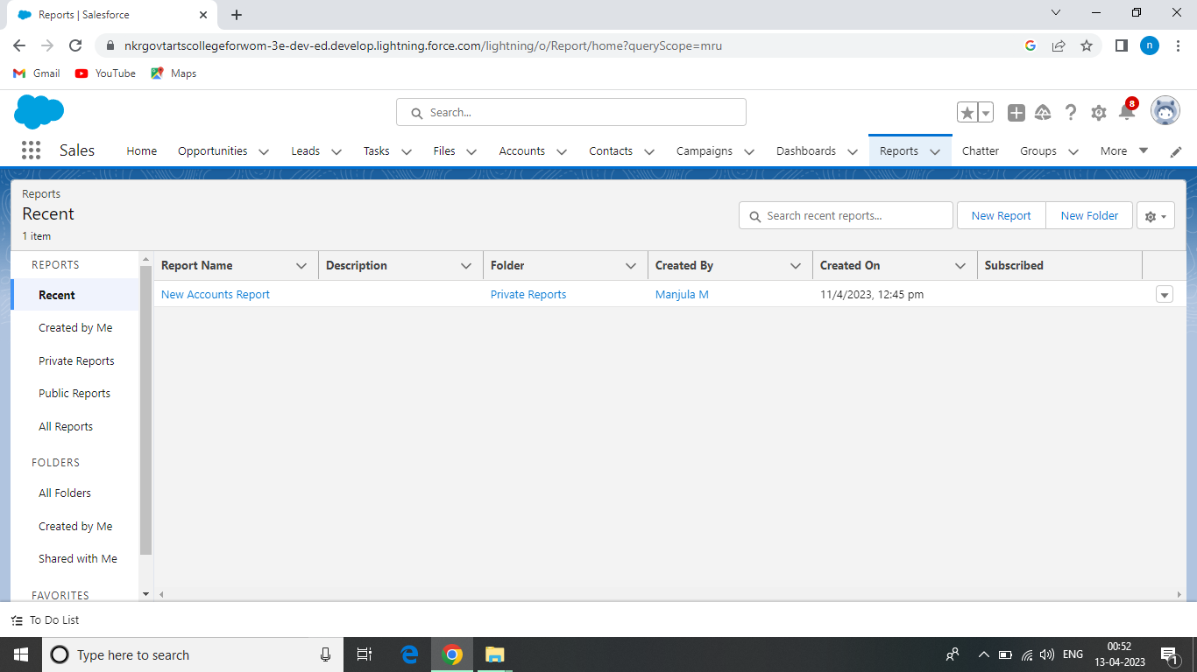

4 Trailhead Profile Public URL

Team Lead : <https://trailblazer.me/id/naths16>

Team member 1: <https://trailblazer.me/id/lavam17>

Team member 2: [https://trailblazer.me/id/manjula444](https://trailblazer.me/id/manjula144)

Team member 3: <https://trailblazer.me/id/monib20>

1. ADVANTAGES

* Using applicant tracking software seems like a great way of saving time when recruiting
* Reduces time spent
* Allows posting of jobs
* Ensures Legal compliment

DISADVANTAGE

There could be some drawbacks, like perhaps missing out on good applicant.

1. APPLICATION
   * Speed up the hiring process
   * Streamline hiring process.
   * Improves the candidate experience.
   * Able to get valuable insights.
   * Easy customatically.
2. CONCLUSION

Like with all technology, there are benefits and drawbacks to using applicant tracking system.

1. FUTURE SCOPE

The application of artificial intelligence (AI) to recruitment functions allows to automate some parts of the recruiting process, helping recruiters connect to tap talent faster.